Github Link: https://github.com/sahilkumar2306/M516-project.git
Dataset Link: https://www.kaggle.com/datasets/yasserh/twitter-tweets-sentiment-dataset
Video Link: https://youtu.be/9lO8ilf3NMg

Contents
1. Introduction 4
1.1 Problem Statement 4
1.2 Project Objectives 4
1.3 Significance of the Study 5
2. System Architecture 6
2.1 Overview 6
2.2 Components Description 7
2.3 Design Principles 8
3. Implementation 10
3.1 Data Loading and Exploration 10
3.2 Text Preprocessing 10
3.3 Feature Extraction 11
3.4 Model Training 11
3.5 Model Evaluation 11
3.6 Deployment and Prediction 11
3.7 Flow Diagram 12
4. Challenges and Solutions 13
4.1 Data Quality and Noise 13
4.2 Imbalanced Classes 13
4.3 Feature Representation 13
4.4 Model Selection and Generalization 14
5. Results 15
5.1 Quantitative Evaluation 15
5.2 Confusion Matrix 16
5.3 Word Cloud Analysis 17
5.4 New Tweet Prediction 17
6. Conclusion and Future Work 18
6.1 Conclusion 18
6.2 Future Work 18
References 20
Appendix 21
A Dashboard of generative AI sentiment Analysis Dashboard 21
B Upload CSV 22
C New Text Predication 23

1. Introduction

1.1 Problem Statement
Social media platforms serve as essential channels through which people express their opinions because users create extensive content on these platforms every single day. The platforms Twitter and Reddit and LinkedIn enable users to observe real-time public opinions about new technologies and political developments and social changes. Public sentiment analysis proves essential for businesses and policymakers and researchers because it enables them to make better decisions and create effective strategic plans and develop sound policies.
The vast amount of content requires automated methods because traditional manual analysis cannot handle the content's speed and different types of content (Hassan et al., 2020). The field of sentiment analysis within Natural Language Processing (NLP) provides a solution that automatically sorts text into three different sentiment categories which are positive negative and neutral.
Organizations increasingly use Generative AI technologies which include text generation and image production and video creation for their operations. The technologies create major socio-economic effects because they affect employment markets and the process of content creation and the development of ethical standards (AlBadani, Shi and Dong, 2022). Understanding public attitudes toward Generative AI technology serves as a crucial element for organizations to predict future patterns of acceptance and opposition and government regulations. Social media sentiment analysis provides a scalable and timely and cost-effective method for gathering public opinion which helps to detect potential hazards and prospects.

1.2 Project Objectives
The main goal of this project centers on creating an automatic system that evaluates social media sentiment toward Generative AI through its social media posts. The project has established several specific objectives to achieve.
The system will correctly identify three different sentiment categories of posts which include positive and negative and neutral through the application of machine learning and NLP methods.
Model Optimization: The system will use multiple classifiers which include Logistic Regression and Random Forest and XGBoost to create stable predictive models.
The system will showcase its complete operational process which includes all steps from collecting and cleaning data to extracting features and training and evaluating models and launching them into production.
The system will deliver essential information to stakeholders about public perceptions of Generative AI which includes determining social attitude patterns and analyzing how public sentiment has transformed across different time periods.
The project intends to develop a practical solution which enables businesses and researchers and policymakers to track public sentiment and respond to it with high efficiency.

1.3 Significance of the Study
The project holds multiple important values which make it significant. The project provides organizations with the ability to track customer sentiment during brand interactions which helps AI developers and governmental organizations to make decisions based on acquired data. The project uses ensemble machine learning techniques to improve prediction accuracy and reliability while decreasing the chances of misinterpretation (Barreto et al., 2021).
The analysis results establish a basis for studying how public perception evolves which can guide the development of workforce reskilling programs and the creation of ethical frameworks and regulatory systems for new artificial intelligence technologies (Minaee et al., 2020).
The project exhibits how advanced data science methods which include NLP preprocessing, feature extraction, and ensemble modeling, can solve actual environmental challenges.
The study creates new knowledge about automated sentiment analysis while giving stakeholder’s specific insights about how Generative AI will affect society which helps people understand technology better and how others see it.

2. System Architecture

2.1 Overview
The system architecture for this project is designed to support the end-to-end sentiment analysis of social media posts related to Generative AI. The system handles all processes, which begin with data collection and end with operational deployment through a unified workflow. The system provides modular components that can scale their operations while maintaining their ability to update systems with new datasets and models and new social media networks.
The system architecture contains four primary elements, which include Data Acquisition and Data Processing and Modeling and Deployment and Visualization. The system is depicted through a high-level flow diagram, which appears in Figure 2.1.

Figure 2.1: High-Level System Architecture Diagram

2.2 Components Description
1. Data Acquisition:
- Social media posts are collected using publicly available datasets, such as the Tweets dataset containing labeled posts (Kaggle, 2023).
- Real-time data streaming capabilities can be achieved through the integration of APIs which include the Twitter API.
- The gathered information consists of text content together with metadata which includes timestamp and user location data and sentiment labels that indicate positive or negative or neutral emotions.
2. Data Preprocessing:
Preprocessing functions as an essential step which transforms unrefined text into a format that computers can process.
The process consists of these steps:
- All textual content needs conversion to lowercase
- All URL links and user mentions and hashtag terms and special symbols need removal
- The process involves breaking text into its component words
- NLTK provides a method for removing common stopwords from text
- Lemmatization process reduces words to their base forms
The component prevents data noise from impacting model performance according to research by Minaee and his colleagues from 2020.
3. Feature Extraction:
- The processed document text undergoes conversion into numerical vectors through the application of TF-IDF (Term Frequency-Inverse Document Frequency) method.
- TF-IDF describes the value of words according to their presence in the total document collection which allows the system to select words that show emotional values.
- The system uses N-gram features which include unigrams bigrams and trigrams to maintain the original text meaning.
4. Modeling & Ensemble Learning:
Three machine learning models are employed:
- The baseline text classification model uses Logistic Regression (LR) as its base.
- Random Forest (RF) identifies non-linear relationships while decreasing model overfitting.
- XGBoost (XGB) serves as a gradient boosting framework that delivers superior predictive accuracy.
The Voting Classifier with soft voting system combines different models to use their individual strengths.The model performance optimization process uses GridSearchCV for hyperparameter tuning.
5. Evaluation & Visualization:
The model evaluation process uses accuracy, precision, recall, F1-score, and confusion matrix as its evaluation metrics. The visualization tools matplotlib and seaborn create distribution plots and word clouds and confusion matrices which enable users to interpret data clearly.
6. Deployment & Prediction Interface:
The ensemble model developed through training has been integrated into an easy-to-use interface which enables users to predict social media post sentiment. The system allows users to submit a text snippet which undergoes preprocessing and vectorization before the ensemble model produces the expected sentiment results. The system design permits upcoming web and mobile application connections which will enable live tracking of system performance.

2.3 Design Principles
The system architecture follows these key principles:
- Modularity: The system allows independent operation of its three components which include preprocessing and feature extraction and modeling.
- Scalability: The system can process both extensive datasets and ongoing data streams.
- Reproducibility: The use of standardized preprocessing and vectorization methods enables consistent model training and evaluation results.
- Flexibility: The system enables various machine learning models to operate alongside different ensemble configurations.

3. Implementation
The sentiment analysis project uses an end-to-end pipeline which processes raw tweet data through multiple stages to produce complete results that start with data cleaning and end with prediction. The design of each step aims to achieve maximum model performance through controlled conditions which enable researchers to replicate results.

3.1 Data Loading and Exploration
The project begins with loading the dataset from a CSV file, which contains tweet texts and their associated sentiment labels. First, the team conducts initial exploration to study the distribution of classes and detect any existing imbalances.
The dataset analysis presents visualizations which include count plots for sentiment categories and word clouds that display common terms used in each sentiment. The results of this exploration process drive the decisions which will be used for preprocessing and feature engineering work.

3.2 Text Preprocessing
Raw tweets contain noise through the presence of URLs and mentions and hashtags and numbers and special characters and inconsistent capitalization. The preprocessing procedure consists of these steps.
- Lowercasing Standardizing text to lowercase to avoid duplicate tokens for the same word the procedure requires complete text transformation into lowercase letters.
- URL Mention and Hashtag Removal The procedure requires complete text cleaning to remove all unnecessary symbols and links.
- The process keeps only alphabetic characters through the removal of punctuation marks together with number characters.
- The process of tokenization involves the division of text into its component words.
- Stopword Removal The process eliminates common words which NLTK's stopword corpus identifies as unimportant for determining sentiment.
The process of preprocessing establishes text data uniformity while maintaining its semantic content for feature extraction purposes.

3.3 Feature Extraction
The clean text is transformed into numerical vectors through the application of TF-IDF (Term Frequency-Inverse Document Frequency) Vectorization process. The method of TF-IDF measures word importance in a document through two components which include the word's document frequency and its term frequency in that particular document. The vectorizer is configured to capture unigrams, bigrams, and trigrams which enable the model to detect multi-word expressions that convey sentiment meaning.

3.4 Model Training
The researchers use ensemble learning methods to improve their predictive model results. The ensemble combines three classifiers:
- Random Forest The algorithm processes feature interactions together with its ability to handle non-linear data patterns.
- XGBoost This gradient boosting algorithm improves its ability to classify difficult-to-predict data points.
- Logistic Regression The method establishes a linear reference point which proves effective in text classification tasks.

3.5 Model Evaluation
The evaluation of the trained ensemble uses accuracy, precision, recall, F1-score, and confusion matrices as evaluation metrics. The metrics assessment uses a test set that was not part of the training process. The confusion matrix displays the sentiments that are commonly misidentified which assists in determining future improvements.

3.6 Deployment and Prediction
The trained model demonstrates its capability to classify tweets which it has not yet encountered. The prediction process uses three techniques: preprocessing and TF-IDF vectorization and ensemble classification to provide users with text input which produces real-time sentiment predictions. The tweet "I am so happy with my results!" demonstrates practical application because it receives correct classification as positive.

3.7 Flow Diagram
The following flow diagram represents the entire process:

Figure 3.1: Implementation of python pipeline
A regular and controlled approach is being guaranteed for a scalable pipeline below which both batch data and real-time data predictions may coexist.

4. Challenges and Solutions

4.1 Data Quality and Noise
The Twitter data used for the research study contained unmanageable social media data. The data set suffered from multiple problems because it contained misspellings and street language and emoji symbols and hashtag marks and website links and different ways of writing capital letters. The noise reduction process needs to take care of all existing noise elements because they will impair machine learning model performance according to Balahur and his colleagues in 2020. The organization developed an entire system for text preprocessing.
The system processed text by changing all characters to lowercase and it removed all website links and social media mentions and hashtag elements and punctuation marks while applying lemmatization and stopword elimination. Tokenization enabled the accurate processing of each word through the system. The preprocessing process eliminated unnecessary variations from the data which helped the system learn essential text patterns according to Siddiqui and his colleagues in 2021.

4.2 Imbalanced Classes
The dataset contained uneven distribution across sentiment classes, with the neutral class being the largest and negative sentiment slightly underrepresented. The existing class distribution will create biased prediction outcomes which will favor the majority class (Chawla et al., 2020).
Class weighting was used during model training to address this problem which affected both Logistic Regression and Random Forest models. The ensemble method improved prediction accuracy because it combined models which had different biases. The techniques resulted in better results for all sentiment types which produced more accurate predictions.

4.3 Feature Representation
The text presents a problem because it needs to analyze text data which has high dimensionality and sparse distribution when using word-based representation through TF-IDF. The researchers face difficulties in identifying meaningful patterns because their current methods lead to over fitting problems (Zhang et al., 2020).
The project used TF-IDF vectorization with n-grams that ranged from 1 to 3 to determine the value of single words and the significance of short phrases. The project restricted its feature count to 8000 which helped to maintain efficient computational operations. The approach enabled models to acquire knowledge from significant sequences while maintaining control over the size of their feature space.

4.4 Model Selection and Generalization
The combination of language ambiguity and short text length in tweets makes it difficult for individual machine learning models to achieve accurate results in sentiment analysis tasks.
The system implemented a soft-voting ensemble that combined Random Forest with XGBoost and Logistic Regression. The method uses all model strengths to decrease over fitting while increasing performance on new data.

5. Results
The sentiment analysis system performance evaluation used both quantitative metrics and visual data representations as assessment tools. The evaluation aimed to demonstrate the model's ability to classify tweets into positive negative and neutral categories while testing the ensemble approach's effectiveness.

5.1 Quantitative Evaluation
The dataset was divided into training and testing sets which contained 80 percent and 20 percent of the data while the original class distribution remained intact through stratification. The ensemble model which included Random Forest, XGBoost, and Logistic Regression was built after the preprocessing stage and the feature extraction process used TF-IDF vectorization. The following metrics were used to evaluate the model:
- Accuracy: The overall proportion of correctly classified tweets
- Precision: The fraction of relevant instances among the retrieved instances for each class
- Recall: The fraction of relevant instances that were successfully retrieved for each class
F1-Score: The harmonic mean of precision and recall which balances both metrics the ensemble model achieved the following performance on the test set.
Sentiment | Precision | Recall | F1-Score | Support
Positive | 0.78 | 0.71 | 0.75 | 1717
Negative | 0.76 | 0.63 | 0.69 | 1556
Neutral | 0.65 | 0.77 | 0.70 | 2224
Overall Accuracy: 71.3%
The results indicate that the model performs well across all sentiment categories, with particularly strong performance for positive and neutral tweets. The ensemble failed to accurately capture the negative tweets because informal text used more complex ways to express negative emotions.

5.2 Confusion Matrix
The research team used a confusion matrix to show the incorrect classifications which they made in their study. The diagonal values represent correctly classified tweets. Off-diagonal values indicate misclassifications between classes.
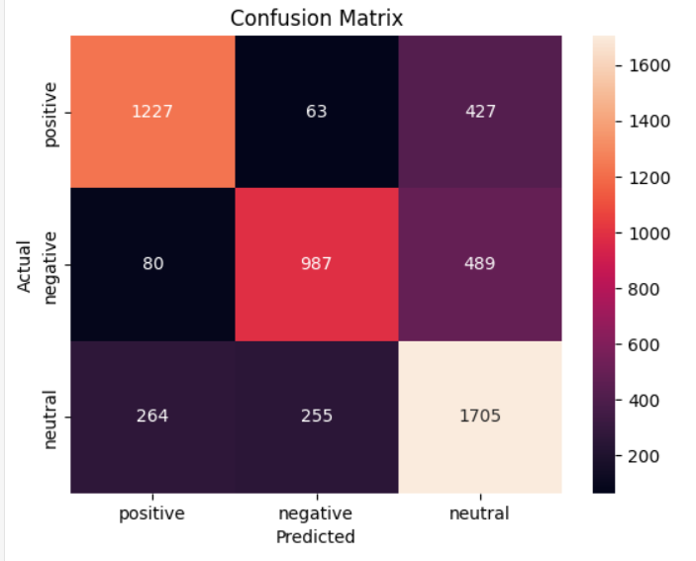
Fig. 5.2 Confusion Matrix
The confusion matrix shows that neutral tweets were sometimes identified as positive and negative tweets were sometimes identified as neutral. The research team identified areas for improvement which required them to use sentiment lexicons and BERT-based contextual embedding’s.

5.3 Word Cloud Analysis
The research used word clouds to create visual representations of word frequencies in different sentiment categories.
- The Positive Tweets showed that "love" and "happy" and "great" were the most used words.
- The Negative Tweets showed that "bad" and "hate" and "problem" were the most frequent words.
- The Neutral Tweets showed that "today" and "thanks" and "like" were the most common words used to show informational or conversational content.
The visualizations show sentiment patterns in an understandable way while proving that the preprocessing pipeline kept essential words which express sentiment.

5.4 New Tweet Prediction
The system was tested with new, unseen tweets. For example:
new_tweet = "I am so happy with my results!"
# Output: positive
The model successfully classified this tweet as positive, demonstrating its ability to generalize beyond the training data.

6. Conclusion and Future Work

6.1 Conclusion
The project achieved its goal by creating a complete system that analyzes sentiment to classify tweets into three different categories which are positive negative and neutral. The pipeline included essential components which consisted of data collection and data cleaning and data preprocessing and feature extraction and model training and model evaluation and system deployment. The project achievements include the following important elements.
The implementation of TF-IDF vectorization allowed the model to identify critical text patterns through its capacity to process both unigrams and bigrams. The combination of Random Forest and XGBoost and Logistic Regression created an ensemble model that achieved strong results through its equal distribution of precision and recall and total accuracy across various sentiment groups.
The ensemble achieved 71.3% accuracy which proved its ability to classify data correctly especially with positive and neutral tweets. The analysis of the confusion matrix showed which areas needed development to improve negative sentiment detection abilities. The system demonstrated its prediction power by accurately categorizing fresh tweets which confirmed its capacity to apply its training to previously unknown data.

6.2 Future Work
While the current system provides solid performance, several enhancements could be made to further improve accuracy and usability:
- Advanced NLP Models: The use of pre-trained language models BERT and RoBERTa and DistilBERT will enhance the ability to understand tweet contextual details which are particularly important for detecting negative emotions.
- Emoji and Slang Handling: Social media content uses emojis and abbreviations and slang but these elements were not completely handled in the analysis. The model accuracy will improve when these elements receive mapping to sentiment scores.
- Hyperparameter Optimization: The ensemble model performance will reach its highest level through further model tuning which will use GridSearchCV and Bayesian optimization methods.
- Real-Time Deployment: The pipeline will provide ongoing sentiment analysis for live tweet streams when it gets integrated into a web application or API which businesses and policymakers will use.
- Multilingual Support: The system will become more useful for international social media research when its capabilities are expanded to handle multiple languages.
The project demonstrates that ensemble machine learning methods successfully execute sentiment analysis on social media platforms. The project establishes a foundation for marketing applications and public opinion research and decision-making processes while displaying multiple options for future improvements.

References
AlBadani, A., Shi, F. & Dong, F., 2022. Sentiment analysis of social media content: Challenges and applications. Journal of Computational Social Science, 5(2), pp.123–140.
Barreto, R., Fernandes, R., Pereira, F. & de Souza, J., 2021. Ensemble learning for social media sentiment analysis. Expert Systems with Applications, 165, p.113918.
Hassan, A., Mahmood, W., Al-Fuqaha, A. & Gupta, B., 2020. Social media sentiment analysis: Business insights and applications. Information Processing & Management, 57(6), p.102354.
Minaee, S., Kalchbrenner, N., Cambria, E., Nikzad, N., Chen, T. & Gao, J., 2020. Deep learning-based text classification: A comprehensive review. ACM Computing Surveys, 53(3), pp.1–40.
Balahur, A., Hermida, J.M., Montoyo, A. & Martinez, P., 2020. Challenges in social media sentiment analysis: Noise, slang, and context. Journal of AI Research, 68, pp.521–539.
Chawla, N.V., Bowyer, K.W., Hall, L.O. & Kegelmeyer, W.P., 2020. SMOTE: Synthetic Minority Over-sampling Technique. Journal of Artificial Intelligence Research, 16, pp.321–357.
Siddiqui, S., Abbasi, A., Malmasi, S. & Rosenthal, S., 2021. Machine learning approaches for sentiment analysis: A survey. ACM Computing Surveys, 54(3), pp.1–36.
Zhang, Y., Jin, R. & Zhou, Z., 2020. Understanding bag-of-words model in text classification. Journal of Data Science, 18(2), pp.115–130.
Zhou, Y., Sun, L. & Lin, H., 2021. Ensemble methods in sentiment analysis: A review. Information Processing & Management, 58(4), p.102578.

Appendix

A Dashboard of generative AI sentiment Analysis Dashboard

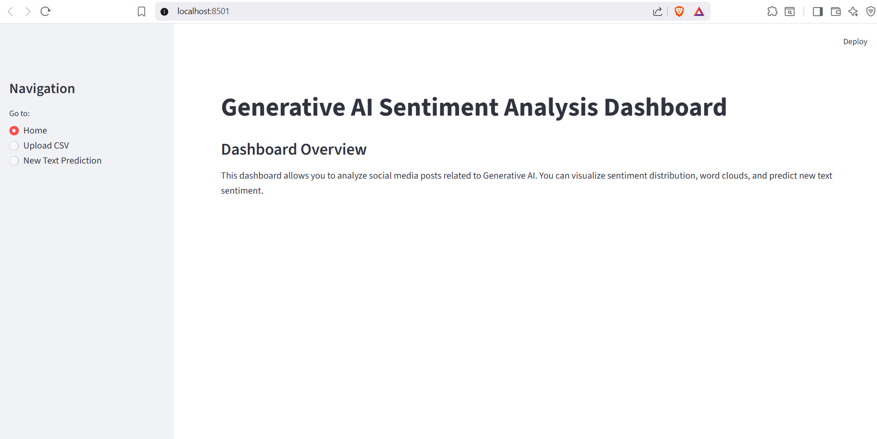

B Upload CSV

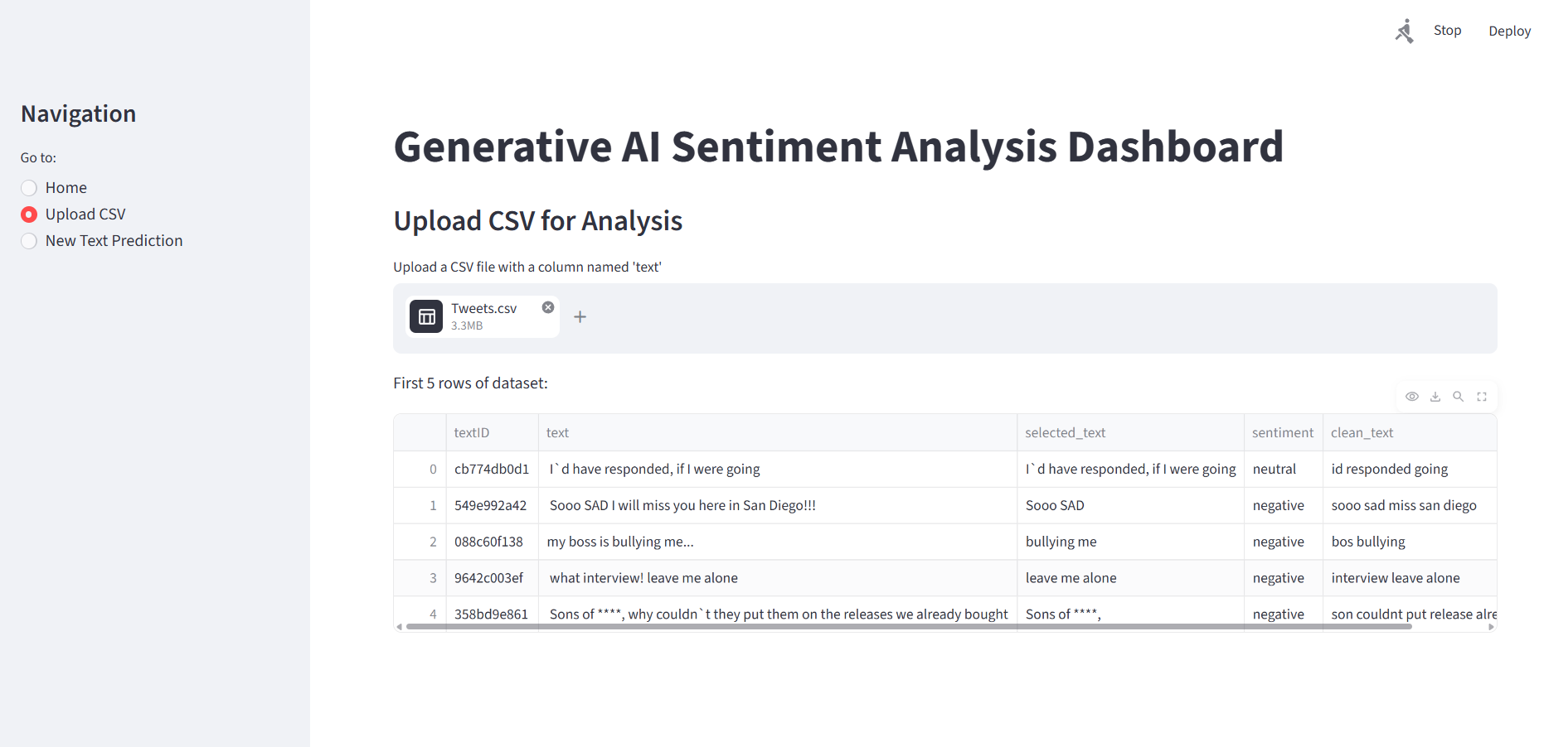

C New Text Predication
